RESERVATION, BOOKING, QUEUING, PAYMENT,
AND SPORTS MANAGEMENT SYSTEM
Development Goal Map and System Feature Specification

Project Overview
The proposed system is an integrated online and offline Reservation, Booking, Queuing, Payment, and Sports Management System designed for ROL-EMS Resort and Rebar Sports Center. The system will allow customers to reserve facilities, join Open Play sessions, make payments, monitor queues, and participate in games with digital scoring. Administrators and staff will manage reservations, facilities, payments, queues, courts, customers, and reports from a centralized system.
Main Establishments
Establishment | Facilities / Services
ROL-EMS Resort | Cottage Reservation; Whole Area Resort Reservation; Pickleball Court Reservation; Pickleball Open Play
Rebar Sports Center | Badminton Court; Ping-Pong; Taekwondo; Dart; Chess Board; Badminton Open Play; Ping-Pong Open Play

ROL-EMS Resort Features
Cottage Reservation
- Select available cottage.
- Select reservation date and time.
- Enter customer and guest information.
- Review reservation details and total cost.
- Select payment method.
- Confirm reservation.
- Generate booking confirmation and receipt.
Whole Area Resort Reservation
- Select whole-resort reservation.
- Select date and time.
- Check availability.
- Enter customer and guest details.
- Calculate the total reservation cost.
- Process payment.
- Confirm the whole-area booking.
- Automatically block the selected period from conflicting reservations.

Pickleball Court Reservation
- View available pickleball courts.
- Select date and time.
- Check real-time availability.
- Enter customer details.
- Process payment.
- Generate booking confirmation.

Rebar Sports Center Features
- Badminton Court Reservation
- Ping-Pong Reservation
- Taekwondo Area Reservation
- Dart Area Reservation
- Chess Board Reservation

The standard reservation process is:
Select Sport/Facility → Select Date & Time → Check Availability → Enter Customer Details → Review Booking → Payment → Confirmation
Open Play Management
Open Play is a separate feature for Pickleball, Badminton, and Ping-Pong. Players join an organized queue instead of reserving a private court.
Sport | Open Play Features | Purpose
Pickleball | Queuing, Payment, Court Assignment, Live Scoring, Match Results, history | Manage shared Open Play sessions
Badminton | Queuing, Payment, Court Assignment, Live Scoring, Match Results, history | Manage shared Open Play sessions
Ping-Pong | Queuing, Payment, Court Assignment, Live Scoring, Match Results, history | Manage shared Open Play sessions

Open Play Flow
Select Sport → Select Open Play Schedule → View Available Slots → Join Queue → Payment → Payment Verification → Waiting Queue → Court/Table Assignment → Play → Live Scoring → Game Finished → Save Results → Next Players
Queuing System
- Display the current players and waiting players.
- Assign queue numbers.
- Show estimated waiting time.
- Add or remove players.
- Skip a player when required.
- Reorder the queue when authorized staff need to make adjustments.
- Assign the next players to an available court or table.
- Update the queue automatically after a game ends.
Scoring System
The system will provide digital scoring for Open Play sessions in Pickleball, Badminton, and Ping-Pong.
- Create a match.
- Register players or teams.
- Record live scores.
- Start and end a game.
- Save match results.
- Display completed game history.
- Move the next players from the queue after the match ends.

Payment Management
Payment will be implemented as a centralized module so the same payment process can support resort reservations, sports reservations, Open Play fees, and additional charges.
- Cash
- GCash
- Maya
- Bank Transfer
- Online Payment Gateway
- Payment verification
- Payment status tracking
- Digital receipt
- Payment history

Online and Offline Capability
Online Features
- Customer registration and login.
- Browse facilities.
- View availability.
- Create reservations and bookings.
- Join Open Play.
- Process online payments.
- View queue status.
- View scores and game results.
- Receive booking confirmation.

Offline Features
- Create walk-in reservations.
- Register walk-in Open Play players.
- Record cash payments.
- Manage queues.
- Assign courts or tables.
- Record game scores.
- Continue basic operations during internet interruption.
Offline records should be stored locally and synchronized with the central database when an internet connection becomes available
User Roles
Role | Main Access | Responsibilities
Administrator | Full system access | Users, facilities, pricing, reservations, payments, queues, scoring, reports, system settings
Staff | Operational access | Walk-in bookings, reservations, queues, court assignment, payments, scoring
Customer | Customer portal | Browse, reserve, book, join Open Play, pay, view queue, view scores, view history

Admin Dashboard
- Today's reservations
- Today's revenue
- Available and occupied cottages
- Available courts and tables
- Active Open Play games
- Waiting players
- Pending payments
- Completed bookings
- Reservation reports
- Payment and revenue reports
- Facility utilization reports
Complete System Goal Map
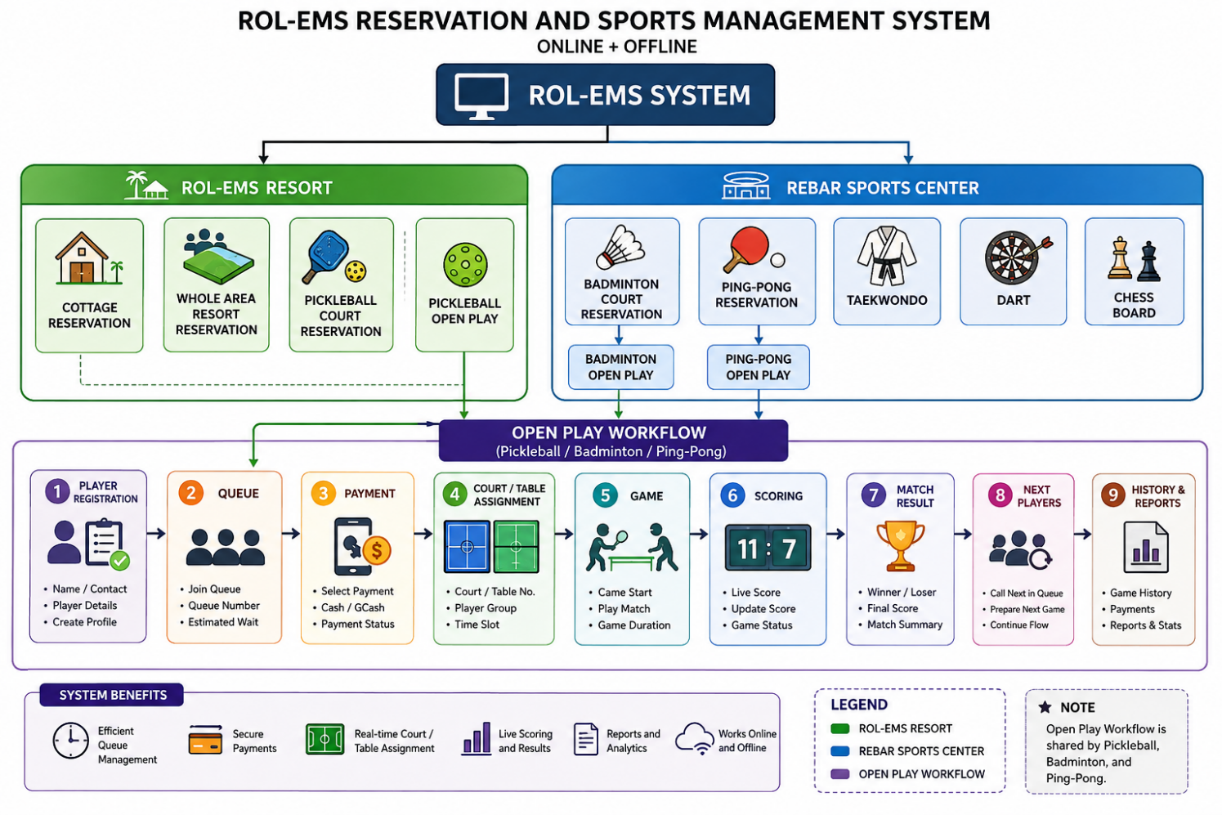

Development Phases
Phase 1 – System Foundation
- User registration/login
- Admin, Staff, and Customer roles
- Database
- Facility management
- Pricing management
Phase 2 – ROL-EMS Resort
- Cottage reservation
- Whole-area reservation
- Pickleball court reservation
- Availability calendar
- Booking confirmation
Phase 3 – Rebar Sports Center
- Badminton
- Ping-Pong
- Taekwondo
- Dart
- Chess
Phase 4 – Open Play
- Pickleball Open Play
- Badminton Open Play
- Ping-Pong Open Play
- Player registration
- Queue management
- Court/table assignment
Phase 5 – Scoring
- Pickleball scoring
- Badminton scoring
- Ping-Pong scoring
- Match history
- Game results
Phase 6 – Payment
- Cash
- GCash
- Maya
- Online payment
- Payment verification
- Receipt and payment history
Phase 7 – Offline Mode
- Local storage
- Offline booking
- Offline queue
- Offline scoring
- Offline payment recording
- Data synchronization
Phase 8 – Reports
- Reservation reports
- Revenue reports
- Facility usage
- Open Play statistics
- Payment reports
- Customer history
Core Project Objective
The main objective is to develop one integrated system for ROL-EMS Resort and Rebar Sports Center that manages the complete customer and staff workflow: facility reservation, booking, availability, payment, Open Play queuing, court or table assignment, digital scoring, match results, offline operations, data synchronization, and management reporting.

